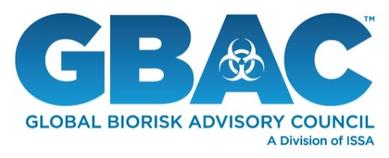
[CONTACT INFO]
FOR IMMEDIATE RELEASE

[FACILITY/ORGANIZATION NAME] Has Achieved GBAC STAR™ Facility Accreditation

[CITY, STATE] – DATE – [FACILITY/ORGANIZATION NAME] has announced that it has achieved Global Biorisk Advisory CouncilTM (GBAC) STAR™ accreditation, the gold standard for prepared facilities. Under the guidance of GBAC, a Division of ISSA, the worldwide cleaning industry association, [FACILITY/ORGANIZATION NAME] has implemented the most stringent protocols for cleaning, disinfection and infectious disease prevention in its facility/facilities.

As the cleaning industry’s only outbreak prevention, response and recovery accreditation, GBAC STAR™ helps organizations establish protocols and procedures, offers expert-led training and assesses a facility’s readiness for biorisk situations. The program verifies that [FACILITY/ORGANIZATION NAME] implements best practices to prepare for, respond to and recover from outbreaks and pandemics.

“GBAC STAR accreditation empowers facility owners and managers to assure workers, customers and key stakeholders that they have proven systems in place to maintain clean and healthy environments,” said GBAC Executive Director Patricia Olinger. “By taking this important step to pursue GBAC STAR, [FACILITY/ORGANIZATION NAME] has received third-party validation that it follows strict protocols for biorisk situations, thereby demonstrating its preparedness and commitment to operating safely.”

To achieve GBAC STAR™ accreditation, [FACILITY/ORGANIZATION NAME] was required to demonstrate compliance with the program’s 20 core elements, which range from standard operating procedures and risk assessment strategies to personal protective equipment and emergency preparedness and response measures. Learn more about GBAC STAR accreditation at www.gbac.org.

About [ORG NAME]
[INSERT ORGANIZATION BOILERPLATE]

About GBAC, a Division of ISSA
Composed of international leaders in the field of microbial-pathogenic threat analysis, mitigation, response, and recovery, the Global Biorisk Advisory Council™ (GBAC), a Division of ISSA, provides training, guidance, accreditation, certification, crisis management assistance and leadership to government, commercial, and private entities looking to mitigate, quickly address, and/or recover from biological threats and real-time crises. The organization’s services include biorisk management program assessment and training, infectious disease and biological material response and remediation, the GBAC STAR™ Facility and Service Accreditation Programs, training and certification of individuals, and consulting for building owners and facility managers. For more information, visit www.gbac.org.

About ISSA
With more than 10,500 members—including distributors, manufacturers, manufacturer representatives, wholesalers, building service contractors, in-house service providers, residential cleaners, and associated service members—ISSA is the world’s leading trade association for the cleaning industry. The association is committed to changing the way the world views cleaning by providing its members with the business tools they need to promote cleaning as an investment in human health, the environment, and an improved bottom line. Headquartered in Northbrook, Ill., USA, the association has regional offices in Milan, Italy; Whitby, Canada; Parramatta, Australia; Seoul, South Korea; and Shanghai, China. For more information about ISSA, visit www.issa.com or call 800-225-4772 (North America) or 847-982-0800.

###

