GBAC STAR™ Registered Technology Requirements

START HERE: READ FIRST

Application fee is for GBAC to conduct a thorough review of the claims you make about your program or technology, safety and certifications, practicality, learning material, marketing language, and environmental and sustainability elements. A detailed report will be provided outlining your total score, next steps, and registration status. Applying to the program does not guarantee registration.

GBAC is now offering manufacturers and other companies the opportunity to have their programs or technologies related to infectious disease prevention achieve the GBAC Registered Seal. The successful registration provides assurance to customers and manufacturers/companies, that the program or technology has been assessed by the GBAC Advisory Council Scientific Board for scientific validity, usability, practicality, safety, and efficacy.

Requirements need to be met and verified by the GBAC Advisory Council Scientific Board before a specific technology is registered. Only technology that are marketed and commercially available will be able to be registered.

The program is a form of recognition and as such requires clear and tangible benefits primarily to the user/purchaser.

Note:

The GBAC STAR™ Registered Technology Program does not apply to:
- Chemical cleaners and disinfectants covered under the EPA Pesticide Act- the Federal Insecticide, Fungicide, and Rodenticide Act (FIFRA).
- Prototypes, proof of concepts, etc.

All required documents must include and meet the following criteria:

- DO NOT use hyperlinks or reference website content. Only text entered into this template will be considered for review.

- Your responses must be exact to the question being asked. If answers are difficult to locate or interpret, your submission may be rejected. For example, uploading an existing brochure is unacceptable.

- A detailed description of the product, outlining its purpose, function, and use.

- A separate listing of all claims (marketing) for the product and (scientific) evidence.

- Submission of all consumer-facing documents, including:
  - End-user manuals
  - All marketing collateral including website, brochures, sales sheets, etc.
- A document specifying the cost/benefit of this technology from a buyer/user perspective. *General marketing material is not sufficient.

- A document specifying the advantage over existing approaches/technologies in terms of efficacy, cost, health, and safety, etc. *General marketing material is not sufficient.

- A list of all relevant certifications, adherence to industry standards, and/or regulatory approval for the intended use and application.

- Submission of all consumer safety review and certification with attached evidence.

- An outline detailing any known limitations of the product considering its use and application.

- Scientific-based tests, provide information on the lab, test procedures and applicable laboratory qualifications.

Examples of certifications, adherence to industry standards and/or regulatory approval:

- Scientific basis for claim of performance/functionality
  - For example, in the United States, EPA/FDA registration that is directly linked to product performance. Note: EPA establishment numbers do not constitute performance approval.
  - Independent 3rd party testing according to standardized, industry accepted criteria
  - Test results have been published and are consumer accessible (anyone can see them at no charge).
  - Limitations of testing and results have been identified and are published (e.g., test setup, number tests, deviations…).
  - Other pertinent information or registrations that the manufacture believes may apply.
- Consumer safety review and certification
  - Technology meets any, and all applicable regulatory requirements for functionality, safety, and performance in the country/region/locality of distribution. Examples: UL, CE, marks
    - Electrical safety
    - Chemical safety
    - Mechanical safety
- Other pertinent information or registration that the manufacture believes may apply.
  - Example: Green Seal Certification, ORMI (organic listed), etc.

Claim validation:

Under the U.S. Federal Trade Commission Act: Advertising must be truthful and nondeceptive. Advertisers must have evidence to back up their claims. A representation, omission or practice is deceptive if it is likely to:
- Mislead consumers and
- Affect consumers' behavior or decisions about the product or service.

In addition, claims must be substantiated, especially when they concern health, safety, or performance. The type of evidence may depend on the technology, the claims, and what experts believe necessary. If your ad specifies a certain level of support for a claim - "tests show X" - you must have at least that level of support.

- Disclaimers and disclosures must be clear and conspicuous. That is, consumers must be able to notice, read or hear, and understand the information. Still, a disclaimer or disclosure alone usually is not enough to remedy a false or deceptive claim.
- Demonstrations must show how the technology will perform under normal and real life use and situations.

HOW YOU WILL BE SCORED

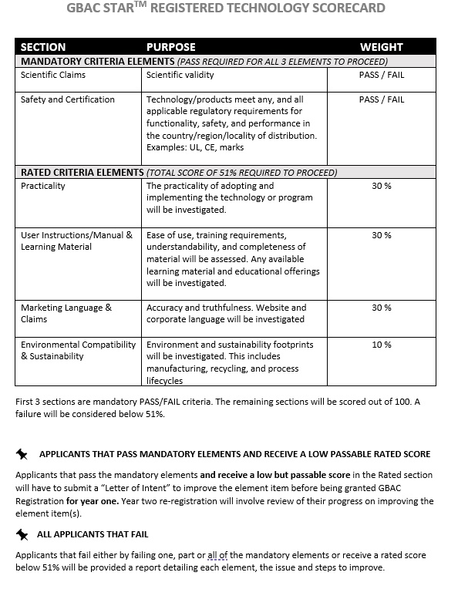

OFFICIAL APPLICATION: Applicant to complete the following

ORGANIZATION:
POINT OF CONTACT:
TECHNOLOGY NAME:
MODEL NUMBER:
MANUFACTURER DATE:
DATE SUBMITTED:

Instructions: Please complete the tables below.
- In Table 1, please include the name of the document submitted for easy reference during the review process. You will be able to upload these documents with this template at the time of submission. Only those referenced in this table will be considered for review.
- In Table 2, please reference the number of the document in Table 1 for the requirement it fulfills.
- If a document fulfills more than one requirement, please make a note in the comment section.
- If you do not have document/evidence for a specific requirement available, please indicate in the “Document #” section
- Ensure that each document name includes the number of the requirement (R1_Product Claims.pdf)
- Your responses must be exact to the question being asked. If answers are difficult to locate or interpret, your submission may be rejected. For example, uploading an existing brochure is unacceptable.

Table 1. Documentation

# | Document Name/Format (doc, pdf, etc.) – No hyperlinks or website references
R1
R2
R3
R4
R5
R6
R7
R8
R9

Table 2. GBAC Assessment and Review
 | Required Documentation (R) |  | Document # | Comments  (Please identify any missing documentation in this section)
R1 | Description of technology/product for GBAC review purposes | Clear and concise separate introduction and description on the technology/product
R2 | Listing of claims (marketing) and (scientific) evidence for the claim | Marketing claim
 |  | Scientific evidence
R3 | Consumer facing documents | End-User Manual
Marketing Collateral:
Website (link)
Brochures (pdf)
Sales/Sell Sheets (pdf)
Other….
R4 | Cost/benefit analysis from a buyer perspective | Financial assessment
 |  | Benefit assessment
 | Required Documentation (R) |  | Document # | Comments  (Please identify any missing documentation in this section)
R5 | Demonstrated advantage over existing/other technologies | Efficacy
 |  | Cost
 |  | Health
 |  | Safety
 |  | Other…
R6 | Certifications in adherence to industry standards/regulatory approval | Certificates
 |  | Approval Documents
 |  | Registrations
 |  | Other…
R7 | Consumer safety review with attached evidence | Review
 |  | Certificates
 |  | Other…
R8 | Current limitations | Use
 |  | Application
R9 | Scientific-based tests | Lab information
 |  | Test procedures
 |  | Lab qualifications

Privacy: All GBAC STAR™ Registered Technology reviews are confidential unless expressly shared by participating organization.

