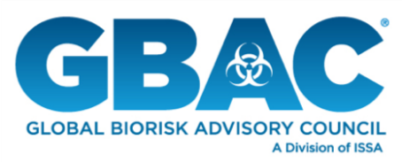
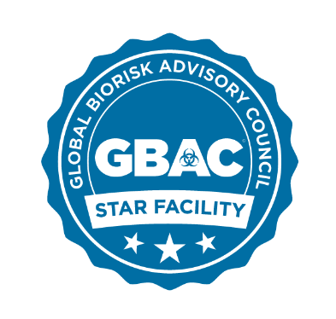

FOR IMMEDIATE RELEASE

Global Biorisk Advisory Council Introduces
GBAC STAR™ Facility Accreditation Program

NORTHBROOK, Ill.—May 7, 2020—The Global Biorisk Advisory Council (GBAC), a Division of ISSA, today introduced its GBAC STAR™ facility accreditation program on cleaning, disinfection, and infectious disease prevention. It is the industry’s only outbreak prevention, response, and recovery accreditation. GBAC STAR establishes requirements to assist facilities with work practices, protocols, procedures, and systems to control risks associated with infectious agents, such as SARS-CoV-2, the virus responsible for COVID-19. Accreditation criteria and facility applications are now available at www.gbac.org.

“GBAC STAR is the gold standard of safe facilities, providing third-party validation that ensures facilities implement strict protocols for biorisk situations,” said GBAC Executive Director Patricia Olinger. “Accreditation empowers facility owners and managers to assure workers, customers, and key stakeholders that they have proven systems in place to deliver clean and healthy environments that are safe for business.”

Ideal for facilities like offices, restaurants, hotels, airports, convention centers, stadiums, and other public venues of all sizes, the GBAC STAR program assesses a facility’s preparedness and provides staff with training for biorisk prevention and containment. The program also establishes a framework for communication and awareness best practices.

Accreditation Criteria & Process
The performance-based GBAC STAR program enables facilities to create and maintain an effective cleaning, disinfection, and infectious disease prevention program. To achieve GBAC STAR accreditation, facilities must demonstrate compliance with the program’s 20 elements, which range from standard operating procedures and risk assessment strategies to personal protective equipment and emergency preparedness and response measures. Facilities will apply online and provide all documentation and supporting evidence with their application. The GBAC STAR Accreditation Council determines the status of all GBAC STAR facilities.

“In the wake of the coronavirus pandemic, the GBAC STAR accreditation program is exactly what facilities need to confidently reopen and keep staff, customers, and communities safe,” said ISSA Executive Director John Barrett. “The way the world views cleaning has changed overnight. To effectively recover from this crisis and prepare for the next, it’s essential that businesses take these necessary steps—and we’re thrilled to have a stable of top organizations that have already committed to the program.”

GBAC STAR Commitments
Several leading organizations have already committed to achieve GBAC STAR accreditation in their facilities. This first wave of leaders planning to pursue facility accreditation includes:

- Hard Rock Stadium in Miami, home to the NFL’s Miami Dolphins
- Hyatt Hotels & Resorts
- VisitDallas, the Dallas Tourism Public Improvement District, Kay Bailey Hutchison Convention Center Dallas and Dallas city-owned arts and cultural institutions
- McCormick Place in Chicago
- Las Vegas Convention and Visitors Authority – Las Vegas Convention Center
- Harry Caray’s Restaurant Group.

Additionally, these prominent industry organizations are among the first to commit their support for GBAC STAR with their thousands of constituents:

- International Association of Venue Managers and its 7,000 member facilities globally
- International Facility Management Association and its 23,000 members worldwide
- Global Market Development Center, the premier global trade association for the retail industry, and its 400-plus members
- Illinois Hotel & Lodging Association and its 400 hotels in the state of Illinois
- Informa Markets and its 500 brands and expositions.
- International Association of Exhibitions and Events and its 12,000 members in 50 countries
- Professional Beauty Association and its 100,000 members
- Media Edge Communications and its portfolio of media products, trade shows and conferences with association partners in Canada
- Trade Show Executive Media
- Go LIVE Together, a coalition of leaders from the live events industry that represent more than 4,000 companies with U.S. operations and 112 other countries.

To learn more about becoming a GBAC STAR accredited facility and submit your application, visit www.gbac.org.

About GBAC, a Division of ISSA
Composed of international leaders in the field of microbial-pathogenic threat analysis, mitigation, response, and recovery, the Global Biorisk Advisory Council (GBAC), a Division of ISSA, provides training, guidance, accreditation, certification, crisis management assistance, and leadership to government, commercial and private entities looking to mitigate, quickly address, and/or recover from biological threats and real-time crises. The organization’s services include biorisk management program assessment and training, Forensic Restoration® response and remediation, the GBAC STAR™ facility accreditation program, training and certification of individuals, and consulting for building owners and facility managers. For more information, visit www.gbac.org.

About ISSA
With more than 9,300 members—including distributors, manufacturers, manufacturer representatives, wholesalers, building service contractors, in-house service providers, residential cleaners, and associated service members—ISSA is the world’s leading trade association for the cleaning industry. The association is committed to changing the way the world views cleaning by providing its members with the business tools they need to promote cleaning as an investment in human health, the environment, and an improved bottom line. Headquartered in Northbrook, Ill., USA, the association has regional offices in Mainz, Germany; Whitby, Canada; Parramatta, Australia; Seoul, South Korea; and Shanghai, China. For more information about ISSA, visit www.issa.com or call 800-225-4772 (North America) or 847-982- 0800.

###

Contact: ISSA Vice President of Marketing Jonathan Adkins at jonathan@issa.com; phone, 847-982-0800 Ext. 1338.

