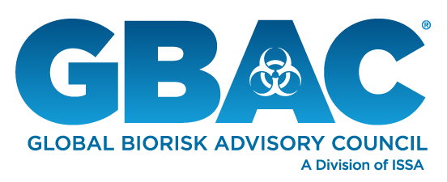
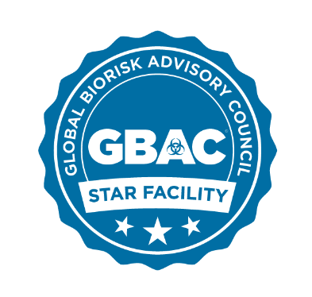

FOR IMMEDIATE RELEASE

Global Biorisk Advisory Council Welcomes New
Facilities Committed to GBAC STAR™ Accreditation Program

NORTHBROOK, Ill.—May 21, 2020—Following the recent debut of its GBAC STAR™ facility accreditation program, the Global Biorisk Advisory Council (GBAC), a Division of ISSA, today announced that additional organizations have committed to accredit their facilities. GBAC STAR is designed for any size facility—including schools, offices, hotels, airports, assisted care facilities, stadiums and other public venues—to establish a comprehensive system of cleaning, disinfection and infectious disease prevention.
Recently committed facilities include:
- Lincoln Financial Field, home to the NFL’s Philadelphia Eagles
- Staples Center in Los Angeles, home to the NBA’s Los Angeles Lakers and Los Angeles Clippers, the NHL’s Los Angeles Kings and the WNBA’s Los Angeles Sparks
- Orange County Convention Center in Orlando, Fla.
- Georgia World Congress Center Authority: Georgia World Congress Center in Atlanta and Savannah Convention Center
- New Orleans Ernest N. Morial Convention Center
- San Diego Convention Center
- Christ Fellowship Church and its locations throughout South Florida
- The Leading Hotels of the World, Ltd., which represents more than 400 hotels in over 80 countries.
In addition to these large-scale facilities, small businesses like Puffy’s Tavern in New York City and La Coutoure Salon in Palos Park, Ill., have committed to pursue accreditation for their facilities, illustrating the broad appeal of GBAC STAR in the marketplace. GBAC STAR also has garnered additional support from leading industry organizations, including:
- Society of Independent Show Organizers (SISO) and its more than 195 members that produce over 3,500 events globally
- Freeman + Go LIVE Together, a coalition of leaders from the live events industry that represent more than 4,000 companies with U.S. operations and 112 other countries
- The Infection Prevention Strategy (TIPS), a nonprofit that extends to 30-plus countries and advances innovations, ideas and processes in global health
- Unique Venues and its 1,100 members throughout the United States and Canada.
“We’re absolutely thrilled with the response that the GBAC STAR program has received and are excited to welcome a new group of dedicated participants,” said GBAC Executive Director Patricia Olinger. “With more and more organizations committing to follow the GBAC STAR framework, we can create a world that values cleanliness and implements it to the highest degree.”
The industry’s only outbreak prevention, response and recovery accreditation, GBAC STAR helps organizations establish protocols and procedures, offers expert-led training and assesses a facility’s preparedness for biorisk situations. The program ensures facilities use best practices to limit future outbreaks, empowers cleaning staff to do their jobs safety and effectively and gives customers greater peace of mind.
“Now is the time for businesses of every size to be transparent about the measures they’re taking to protect customers and employees, including proper cleaning and disinfection,” said ISSA Executive Director John Barrett. “GBAC STAR program participants demonstrate their commitment to going the extra mile by implementing prevention and response best practices that support health and safety.”
Facilities that previously announced they are pursuing GBAC STAR accreditation include: Hard Rock Stadium in Miami; Hyatt Hotels & Resorts; VisitDallas, the Dallas Tourism & Public Improvement District and Kay Bailey Hutchison Convention Center Dallas; McCormick Place in Chicago; the Las Vegas Convention Center; and Harry Caray’s Restaurant Group.
Additional industry groups that previously announced their support of GBAC STAR with their constituents include: International Association of Venue Managers; International Facility Management Association; the Global Market Development Center; Illinois Hotel & Lodging Association; Informa Markets; International Association of Exhibitions and Events; Professional Beauty Association; Media Edge Communications; and Trade Show Executive Media.
For accreditation criteria and facility applications, visit www.gbac.org. To learn more, watch GBAC’s video at https://youtu.be/acrCdc-7pI0.
About GBAC, a Division of ISSA
Composed of international leaders in the field of microbial-pathogenic threat analysis, mitigation, response and recovery, the Global Biorisk Advisory Council (GBAC), a Division of ISSA, provides training, guidance, accreditation, certification, crisis management assistance and leadership to government, commercial and private entities looking to mitigate, quickly address and/or recover from biological threats and real-time crises. The organization’s services include biorisk management program assessment and training, Forensic Restoration® response and remediation, the GBAC STAR™ facility accreditation program, training and certification of individuals and consulting for building owners and facility managers. For more information, visit www.gbac.org.

About ISSA
With more than 9,300 members—including distributors, manufacturers, manufacturer representatives, wholesalers, building service contractors, in-house service providers, residential cleaners and associated service members—ISSA is the world’s leading trade association for the cleaning industry. The association is committed to changing the way the world views cleaning by providing its members with the business tools they need to promote cleaning as an investment in human health, the environment and an improved bottom line. Headquartered in Northbrook, Ill., USA, the association has regional offices in Mainz, Germany; Whitby, Canada; Parramatta, Australia; Seoul, South Korea; and Shanghai, China. For more information about ISSA, visit www.issa.com or call 800-225-4772 (North America) or 847-982-0800.

###

For more information, contact ISSA Vice President of Marketing Jonathan Adkins at jonathan@issa.com; phone, 847-982-0800 Ext. 1338.

