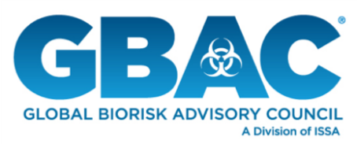
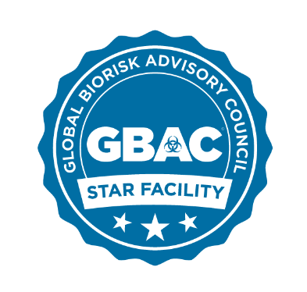

GBAC STARTM Facility Accreditation Program
Official Statements

Patricia Olinger, Executive Director, Global Biorisk Advisory Council
“GBAC STAR is the gold standard of safe facilities, providing third-party validation that ensures facilities implement strict protocols for biorisk situations.”
“Accreditation empowers facility owners and managers to assure workers, customers, and key stakeholders that they have proven systems in place to deliver clean and healthy environments that are safe for business.”

John Barrett, Executive Director, ISSA
“In the wake of the coronavirus pandemic, the GBAC STAR accreditation program is exactly what facilities need to confidently reopen and keep staff, customers, and communities safe.”
“The way the world views cleaning has changed overnight. To effectively recover from this crisis and prepare for the next, it’s essential that businesses take these necessary steps—and we’re thrilled to have a stable of top organizations that have already committed to the program.”

