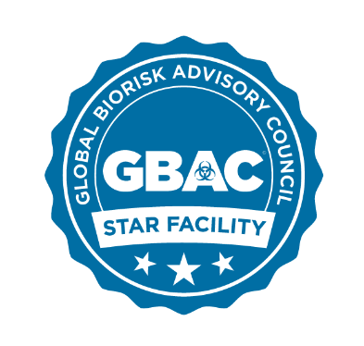

GBAC STARTM Facility Accreditation Program
Marketing & Communications Contact Information

Jonathan Adkins, Vice President of Marketing, ISSA
Email: jonathan@issa.com
Phone: 847-982-0800 Ext. 1338

Allison Fitch-Markham, Director of Marketing Communications, ISSA
Email: allisonf@issa.com
Phone: 847-897-0023 | issa.com

Matt Serra, CEO, Mulberry Marketing Communications
Email: mserra@mulberrymc.com
Phone: 773-817-3106

Alex Weiss, Senior Account Executive, Mulberry Marketing Communications
Email: aweiss@mulberrymc.com
Phone: 651-785-5263

