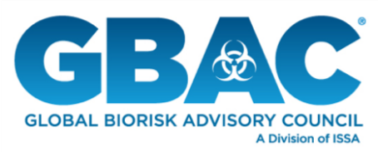
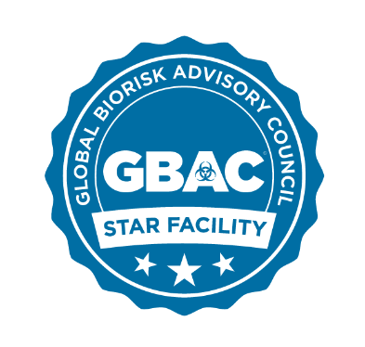

GBAC STAR™ Facility Accreditation Program
Boilerplates

About GBAC, a Division of ISSA
Composed of international leaders in the field of microbial-pathogenic threat analysis, mitigation, response, and recovery, the Global Biorisk Advisory Council (GBAC), a Division of ISSA, provides training, guidance, accreditation, certification, crisis management assistance, and leadership to government, commercial and private entities looking to mitigate, quickly address, and/or recover from biological threats and real-time crises. The organization’s services include biorisk management program assessment and training, Forensic Restoration® response and remediation, the GBAC STAR™ facility accreditation program, training and certification of individuals, and consulting for building owners and facility managers. For more information, visit www.gbac.org.

About ISSA
With more than 9,300 members—including distributors, manufacturers, manufacturer representatives, wholesalers, building service contractors, in-house service providers, residential cleaners, and associated service members—ISSA is the world’s leading trade association for the cleaning industry. The association is committed to changing the way the world views cleaning by providing its members with the business tools they need to promote cleaning as an investment in human health, the environment, and an improved bottom line. Headquartered in Northbrook, Ill., USA, the association has regional offices in Mainz, Germany; Whitby, Canada; Parramatta, Australia; Seoul, South Korea; and Shanghai, China. For more information about ISSA, visit www.issa.com or call 800-225-4772 (North America) or 847-982- 0800.

