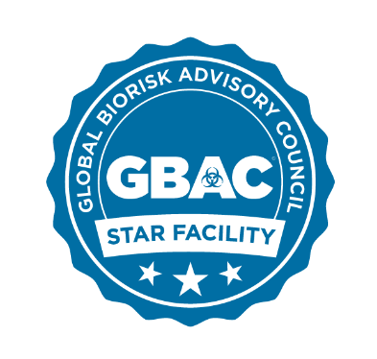

GBAC STARTM Facility Accreditation Program
Official Bios

Patricia (Patty) Olinger, JM, RBP, Certified Forensic Operator®, Certified Bio-Forensic Restoration Specialist®, Executive Director, Global Biorisk Advisory Council (GBAC)
Prior to joining GBAC, Olinger was an Assistant Vice President in the Office of Research Administration and the Executive Director of the Environmental, Health and Safety Office (EHSO) at Emory University. During Olinger’s 13-year tenure, EHSO had university-wide responsibility for all aspects of Environmental, Health and Safety support, including EHS compliance support to Emory Healthcare. This included biosafety support to the Emory Serious Communicable Diseases Unit (SCDU), which cared for four Ebola patients in 2014.
Headshot: https://www.dropbox.com/s/xxhppylbt0npk9t/Patricia%20Olinger.png?dl=0

Gavin Macgregor-Skinner, BVSc, MSc, MPH, MRCVS, Certified Forensic Operator®, Certified Bio-Forensic Restoration Specialist®
Dr. Macgregor-Skinner has more than 25 years of technical experience in emergency management and infectious disease surveillance and response and has worked with U.S. and international governments, United Nations agencies, and the private sector in the U.S., Africa, Asia, Middle East, and Latin America. He is an assistant professor in the Department of Public Health Sciences at Penn State Hershey College of Medicine and Director of Global Disaster Response for the BIDMC Fellowship in Disaster Medicine affiliated with Harvard Medical School.
Headshot: https://www.dropbox.com/s/hvzf6mlfrwhm98d/Gavin%20Macgregor-Skinner.jpg?dl=0

John Barrett, Executive Director, ISSA – The Worldwide Cleaning Industry Association
Barrett’s more than 35 years of experience includes serving as CEO, president, vice chair, trustee, and board director at some of the leading companies in the technology, manufacturing, distribution, private equity, and service industries. His experience includes accepting increasing levels of responsibility at such well-known companies as Frontenac, SMS Assist, Compass Group, Kimco Corp., York Management, Gemini Industries, Ogden Allied, and Xerox. Prior to becoming ISSA’s Executive Director, Barrett served as an ISSA Board member for six years, with three as an officer and one year as treasurer. An Evans Scholar, Barrett graduated from the University of Michigan in 1981 with a degree in economics and speech communications. He earned his MBA with an emphasis in finance and marketing from the University of Chicago in 1986.
Headshot: https://www.dropbox.com/s/jcgsaqxc6gemubu/Barret%2CJohn_2017_7756.jpg?dl=0

To request an interview, please contact ISSA’s Vice President of Marketing Jonathan Adkins at jonathan@issa.com.

